SOFTWARE REQUIREMENTS SPECIFICATION

For

Student Attendance Management System

Prepared by:-
Sabhareeswaran S-22EC131
Sri Krishna M-22EC164
Vigneshkumar R-22EC186

Introduction

Purpose
The main objective of this document is to illustrate the requirements of the project Attendance Management system. The document gives the detailed description of the both functional and non-functional requirements proposed by the client The purpose of this project is to provide a friendly environment to maintain the details of Student, Instructor and Course data. The main purpose of this project is to maintain easy circulation system using computers and to provide different reports. This project describes the hardware and software interface requirements using ER diagrams and UML diagrams.

Document Conventions
    - Entire document should be justified.

    - Convention for Main title
Font face: Times New Roman Font style: Bold
Font Size: 14
    - Convention for Sub title
Font face: Times New Roman Font style: Bold
Font Size: 12

    - Convention for body
Font face: Times New Roman Font Size: 12

Scope of Development Project
The proposed Attendance Management System, modeled after the concept of updating manual systems into internet-based applications, seeks to provide an efficient solution for tracking attendance in educational institutions.
This Java-based project is specifically tailored for both administrators and users, functioning as a comprehensive user interface for attendance management processes. The system facilitates real-time access to attendance details, allowing users to stay informed about their records and maximum limits for attendance. With a robust integration of JavaFX and DBMS connectivity, the system ensures a user-friendly interface and efficient data storage and retrieval. Ideal for educational institutes, it allows easy customization according to specific requirements. The system's modular flexibility enables seamless implementation under various scenarios, allowing for the addition of new features as needed.
Leveraging Java's advantages in performance, cross-platform compatibility, and cost-effectiveness, the Attendance Management System offers a scalable and adaptable solution for monitoring and reporting attendance with ease.

Definitions, Acronyms and Abbreviations
JAVA -> platform independence SQL-> Structured query Language ER-> Entity Relationship
UML -> Unified Modeling Language
IDE-> Integrated Development Environment SRS-> Software Requirement Specification

References

Books

➢ Learn JavaFX 17: Building User Experience and Interfaces with Java by Kishori Sharan

➢ The Definitive Guide to Modern Java Clients with JavaFX 17: Cross-Platform Mobile and Cloud Development by James Weaver

Websites

WWW.geeksforgeeks.com/javafxtutotials

Www.w3schools.com/javafxtutorials

Overall Descriptions

Product Function
Entity Relationship Diagram of Student Attendance Management System
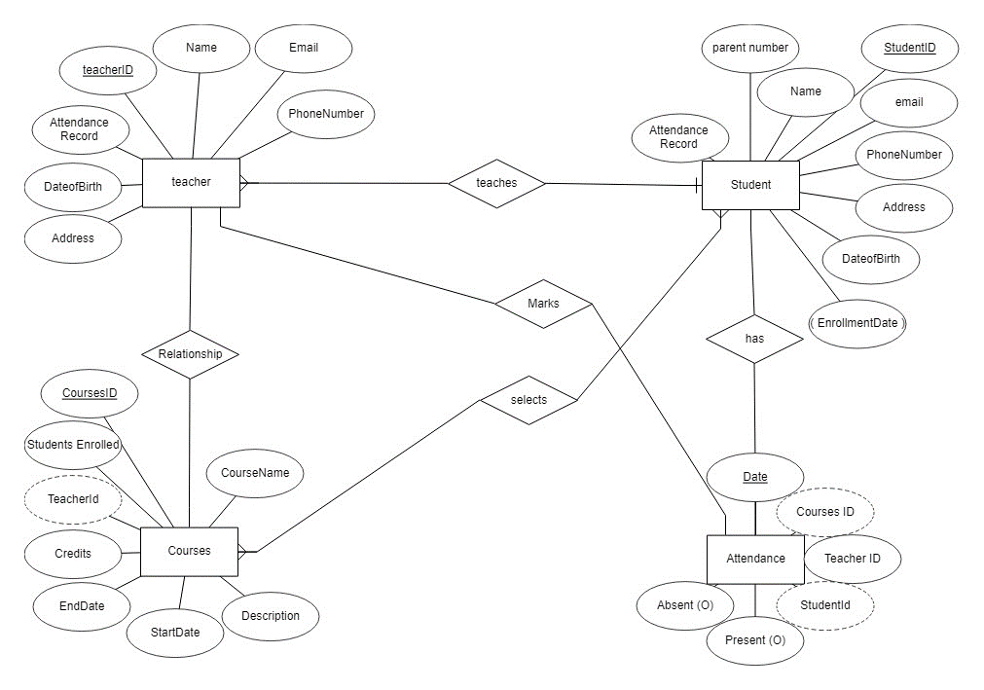

The Student Attendance Management System offers real-time access to attendance information, providing efficient and automated tracking of student attendance records. The primary objective is to streamline manual processes, reducing administrative workload. This software effectively manages attendance recording, calculates and manages attendance-related data, and generates comprehensive reports for record-keeping based on user preferences. The system designates the administrator, typically a teacher or school official, to oversee student attendance and system functions. Student attendance status, including records of attendance and absences, is systematically stored in the database. The system enables administrators to retrieve student details promptly as needed. Valid students can also access their attendance records and related information through the system, promoting transparency and accountability. The Student Attendance Management System optimizes attendance monitoring, offering an automated and user-friendly solution for educational institutions.

User Classes and Characteristics
The system provides different types of services based on the type of users [Tutor/Instructor]. The Instructor will be acting as the controller and he will have all the privileges of an administrator. The member can be either a student or staff of the university who will be accessing the attendance online.
The features that are available to the Teacher are:-
    - Record and manage student attendance data.
    - View different categories of attendance records.
    - Add new students to the system.
    - Edit and update student information as needed.
    - Generate reports on overall attendance trends.
    - Access reports on individual student attendance.
    - Utilize DBMS connectivity to ensure efficient storage and retrieval of attendance data.
    - Perform administrative tasks related to database maintenance.
    - Access all student accounts for attendance monitoring.
    - Perform account-related actions, such as password resets.

The features that are available to the Student are:-
    - View personal attendance records.
    - Check attendance history for specific time periods.
    - Own a personal account for attendance tracking.
    - Put in requests for attendance correction or adjustments.
    - Search for specific attendance-related information.
    - Request additional details or clarifications on attendance records.
    - View different categories of attendance data.
    - View the attendance records for individual classes or subjects.

Operating Environment
The product will be operating in windows environment. The Attendance Management System is a website and shall operate in all famous browsers, for a model we are taking Microsoft Internet Explorer,Google Chrome,and Mozilla Firefox.Also it will be compatible with the IE 6.0. Most of the features will be compatible with the Mozilla Firefox & Opera 7.0 or higher version. The only requirement to use this online product would be the internet connection.
The hardware configuration include Hard Disk: 40 GB, Monitor: 15” Color monitor, Keyboard: 122 keys. The basic input devices required are keyboard, mouse and output devices are monitor, printer etc.

Assumptions and Dependencies
The assumptions are:-
    - The coding should be error free
    - The system should be user-friendly so that it is easy to use for the users
    - The information of all users, books and libraries must be stored in a database that is accessible by the website
    - The system should have more storage capacity and provide fast access to the database
    - The system should provide search facility and support quick transactions
    - The Attendance System is running 24 hours a day
    - Users may access from any computer that has Internet browsing capabilities and an

Internet connection
    - Users must have their correct usernames and passwords to enter into their online accounts and do actions

The dependencies are:-
    - The specific hardware and software due to which the product will be run
    - On the basis of listing requirements and specification the project will be developed and run
    - The end users (admin) should have proper understanding of the product
    - The system should have the general report stored
    - The information of all the users must be stored in a database that is accessible by the Library System
    - Any update regarding the book from the library is to be recorded to the database and the data entered should be correct

Requirement
Software Configuration:-
This software package is developed using java as front end which is supported by sun micro system. Microsoft SQL Server as the back end to store the database.
Operating System: Windows NT, windows 98, Windows XP Language: Java Runtime Environment, Net beans 7.0.1 (front end) Database: MS SQL Server (back end)

Hardware Configuration:- Processor: Pentium(R)Dual-core CPU Hard Disk: 40GB
RAM: 256 MB or more

Data Requirement
The inputs consist of the query to the database and the output consists of the solutions for the query. The output also includes the user receiving the details of their accounts. In this project the inputs will be the queries as fired by the users like create an account, selecting books and putting into account. Now the output will be visible when the user requests the server to get details of their account in the form of time, date and which books are currently in the account.

External Interface Requirement

GUI
The software provides good graphical interface for the user and the administrator can operate on the system, performing the required task such as create, update, viewing the details of the book.
    - It allows user to view quick reports like student Present/absent in between particular time.
    - It provides Attendance and search facility based on different criteria.
    - The user interface must be customizable by the administrator
    - All the modules provided with the software must fit into this graphical user interface and accomplish to the standard defined
    - The design should be simple and all the different interfaces should follow a standard

template
    - The user interface should be able to interact with the user management module and a part of the interface must be dedicated to the login/logout module
Login Interface:-
In case the user is not yet registered, he can enter the details and register to create his account. Once his account is created he can ‘Login’ which asks the user to type his username and password. If the user entered either his username or password incorrectly then an error message appears.

Search:-
The teacher can enter the student he is looking for and verify his details and attendance of a particular day

Teacher’s Control Panel:-
This control panel will allow Teacher to mark present/absent users; add, edit, or remove a resource. And manage lending options.

System Features
The users of the system should be provided the surety that their account is secure. This is possible by providing:-
- User authentication and validation of members using their unique Student ID
- Proper monitoring by the administrator which includes updating account status, showing a popup if the member attempts to issue number of absents that exceed the limit provided by the college policy, assigning report to parent .
- Proper accountability which includes not allowing a member to see other member’s account. Only administrator will see and manage all member accounts

Other Non-functional Requirements

Performance Requirement
The proposed system that we are going to develop will be used as the Chief performance system within the different campuses of the university which interacts with the university staff and students. Therefore, it is expected that the database would perform functionally all the requirements that are specified by the university.
    - The performance of the system should be fast and accurate
    - Attendance Management System shall handle expected and non-expected errors in ways that prevent loss in information and long downtime period. Thus it should have inbuilt error testing to identify invalid username/password
    - The system should be able to handle large amount of data. Thus it should accommodate high number of students and users without any fault

Safety Requirement

The database may get crashed at any certain time due to virus or operating system failure. Therefore, it is required to take the database backup so that the database is not lost. Proper UPS/inverter facility should be there in case of power supply failure.

Security Requirement
    - System will use secured database
    - Normal users can just read information but they cannot edit or modify anything except their personal and some other information.
    - System will have different types of users and every user has access constraints
    - Proper user authentication should be provided
    - No one should be able to hack users’ password
    - There should be separate accounts for admin and members such that no member can access the database and only admin has the rights to update the database.

Requirement attributes
    - There may be multiple admins creating the project, all of them will have the right to create changes to the system. But the members or other users cannot do changes
    - The project should be open source
    - The Quality of the database is maintained in such a way so that it can be very user friendly to all the users of the database
    - The user be able to easily download and install the system

Business Rules
A business rule is anything that captures and implements business policies and practices. A rule can enforce business policy, make a decision, or infer new data from existing data.This includes the rules and regulations that the System users should abide by. This includes the cost of the project and the discount offers provided. The users should avoid illegal rules and protocols. Neither admin nor member should cross the rules and regulations.

User Requirement
The users of the system are members and Librarian of the university who act as administrator to maintain the system. The members are assumed to have basic knowledge of the computers and internet browsing. The administrators of the system should have more knowledge of the internals of the system and is able to rectify the small problems that may arise due to disk crashes, power failures and other catastrophes to maintain the system. The proper user interface, user manual, online help and the guide to install and maintain the system must be sufficient to educate the users on how to use the system without any problems.
The admin provides certain facilities to the users in the form of:-
    - Backup and Recovery
    - Forgot Password
    - Data migration i.e. whenever user registers for the first time then the data is stored in the server
    - Data replication i.e. if the data is lost in one branch, it is still stored with the server
    - Auto Recovery i.e. frequently auto saving the information
    - Maintaining files i.e. File Organization
    - The server must be maintained regularly and it has to be updated from time to time

Other Requirements

Data and Category Requirement
There are different categories of users namely teaching staff,Students,Administrartion and Parents etc. Depending upon the category of user the access rights are decided.It means if the user is an administrator then he can be able to modify the data,delete, append etc. All other users except the Teacher only have the rights to the modify the Attendance about database. According to the categories of books their relevant data should be displayed. The categories and the data related to each category should be coded in the particular format.

Appendix
A: Admin, Abbreviation, Acronym, Assumptions; B: Books, Business rules; C: Class, Client, Conventions; D: Data requirement, Dependencies; G: GUI; K: Key; L: Library, Librarian; M: Member; N: Non-functional Requirement; O: Operating environment; P: Performance,Perspective,Purpose; R: Requirement, Requirement attributes; S: Safety, Scope, Security, System features; U: User, User class and characteristics, User requirement;

Glossary
The following are the list of conventions and acronyms used in this document and the project as well:
    - Administrator: A login id representing a user with user administration privileges to the software
    - User: A general login id assigned to most users
    - Client: Intended users for the software
    - SQL: Structured Query Language; used to retrieve information from a database
    - SQL Server: A server used to store data in an organized format
    - Layer: Represents a section of the project
    - User Interface Layer: The section of the assignment referring to what the user interacts with directly
    - Application Logic Layer: The section of the assignment referring to the Web Server. This is where all computations are completed
    - Data Storage Layer: The section of the assignment referring to where all data is recorded
    - Use Case: A broad level diagram of the project showing a basic overview
    - Class diagram: It is a type of static structure diagram that describes the structure of a system by showing the system’s cases, their attributes, and the relationships between the classes
    - Interface: Something used to communicate across different mediums
    - Unique Key: Used to differentiate entries in a database

Class Diagram
A class is an abstract, user-defined description of a type of data. It identifies the attributes of the data and the operations that can be performed on instances (i.e. objects) of the data. A class of data has a name, a set of attributes that describes its characteristics, and a set of operations that can be performed on the objects of that class. The classes’ structure and their relationships to each other frozen in time represent the static model. In this project there are certain main classes

which are related to other classes required for their working. There are different kinds of relationships between the classes as shown in the diagram like normal association, aggregation, and generalization. The relationships are depicted using a role name and multiplicities. Here ‘Student’, ‘Teacher’,’Attendance’ and ‘Courses’ are the most important classes which are related to other classes.

